

**AMERICAN INTERNATIONAL UNIVERSITY**

Department: Computer science and engineering

Faculty of science and Technology (FST)

Spring 20-21

PROJECT REPORT

**Project Title: Dynamic Beach View**

REPORT SUBMITTED BY:

**Name: Maksudul Haque**

**ID: 18-36962-1**

**Course: Computer Graphics  
Sec: A**

**Group: H**

**Submitted TO: Dipta Justin Gomes**

**Date: 24/04/2021**

1. INTRODUCTION:The project will demonstrate a minimal look of a sea shore scene. We implemented a scenario of three view which are day, night and evening; there will be rain feature in all of the views by the button press. There will sound effect of each difference scene. All together it would render an eye pleasing sea beach scenario. Our program provides fast and accurate rendering of the objects. as well as a landscape to simulate a sea beach. In this paper, we explain the motivation for this model, then describe the algorithms used. We finish up with some ideas for future work and some of the bugs we encountered.

2. BACKGROUND:The process of implementation of the views are mainly relying on the vector graphics. They are based on mathematical formulas that define geometric primitives such as polygons, lines, curves, circles and rectangles. Using this formula OpenGL is an API that is highly usable for rendering basic 2D/3D graphics. Vector graphics are composed of true geometric primitives, they are best used to represent more structured images, like line art graphics with flat, uniform colors. The GL primitives are using C/C++ programming language. Many Opengl primitives were used to develop the objects.

3. OBJECTIVES:Our objective is to develop a sea beach containing sea water with running sea wave, an amazing sky with sun moon and clouds pleasingly animated. All these objects will show up in both night view and day views with raining effect including sound. Moreover, the sea shore would have seating places for tourists. Our goal is to render a minimal look of a sea beach.

4. SYSTEM IMPLEMENTATION METHOD:In the entire project we used OpenGL primitives for rendering the sea beach. Speaking of  
OpenGL, it is a cross-language, cross-platform application programming interface for  
rendering 2D and 3D vector graphics. The API is typically used to interact with a graphics  
processing unit, to achieve hardware-accelerated rendering.

5. SIGNIFICANCE:The key feature of the project is implemented using the OpenGL primitives. It renders every  
object faster than typical new graphics rendering. Our project would be simple enough to run  
on any device including windows and macs. The sound play feature will also play the sound  
effect of each views that provides a user the best experience.

6. CONCLUSION:We have implemented an automatic view of sea-beach scenario where day night and evening  
are automatically time lapsing. The rain feature is implemented using the Line primitives. The  
color of the sand and other object is variable with the views of the scene. The program runs  
everything with some relevant sound effect regarding the view effect of the scene. In future we  
would like to develop this project into a 3D architecture which can turn this into more eye  
soothing to the user.

**7. Screenshot:**

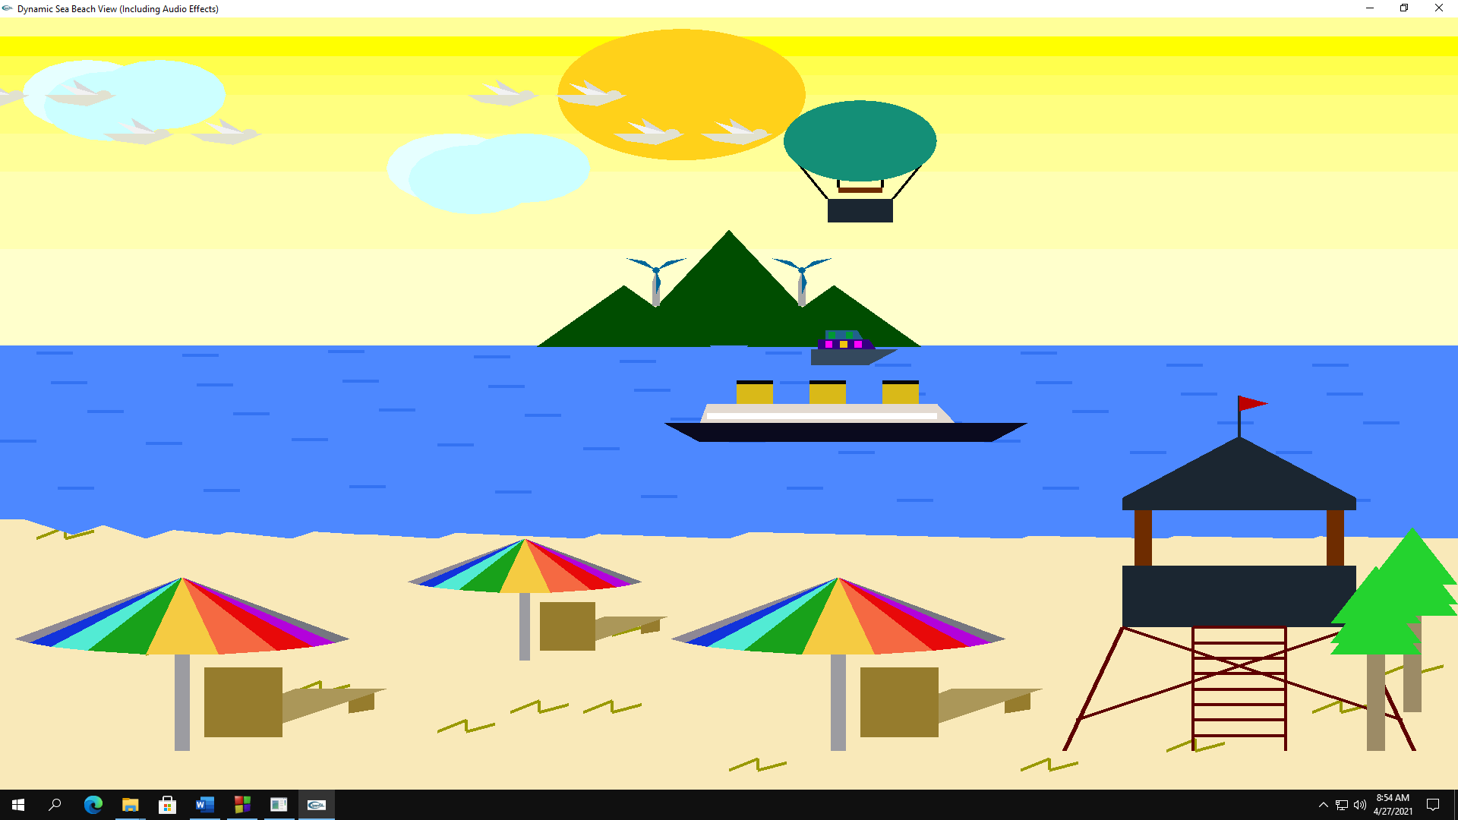

Fig: Dynamic Beach View Without Rain

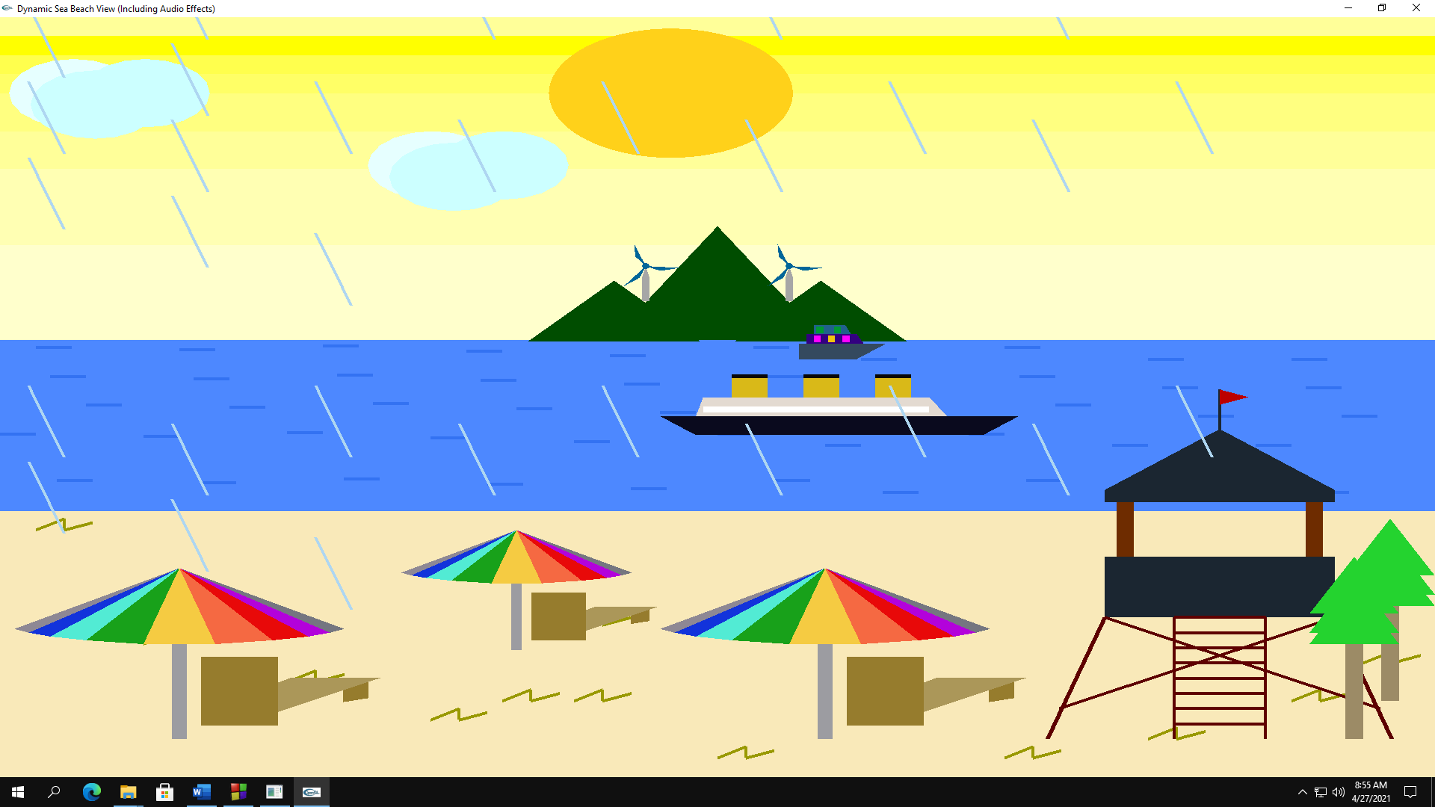

Fig: Dynamic Beach View With Rain